Arkusz1

PHOTO | BRAND | MODEL | COLOUR | RRP | Tot | S | M | L | XL | XXL
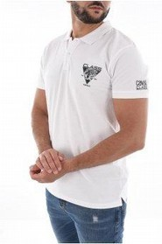 | Cavalli Class | SXT64A KB002 | WHITE | 49,90 € | 161 | 5 | 56 | 40 | 60 | 0
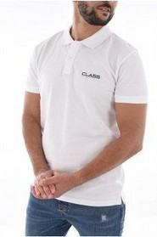 | Cavalli Class | SXT64B KB002 | WHITE | 69,00 € | 86 | 6 | 16 | 44 | 19 | 1
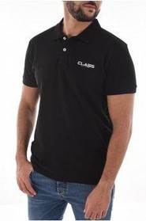 | Cavalli Class | SXT64B KB002 | BLACK | 69,00 € | 49 | 15 | 15 | 19 | 0 | 0
 | Cavalli Class | SXT64A KB002 | BLACK | 69,00 € | 35 | 6 | 0 | 29 | 0 | 0
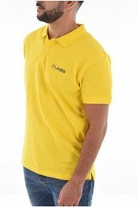 | Cavalli Class | SXT64B KB002 | YELLOW | 69,00 € | 30 | 5 | 9 | 16 | 0 | 0

361 units

